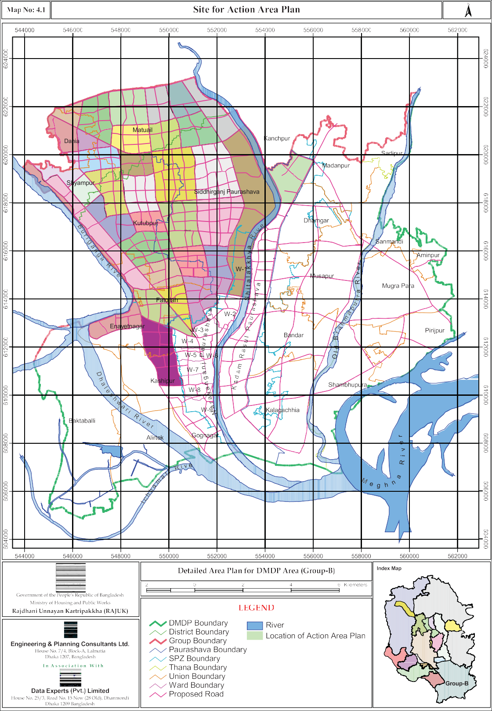

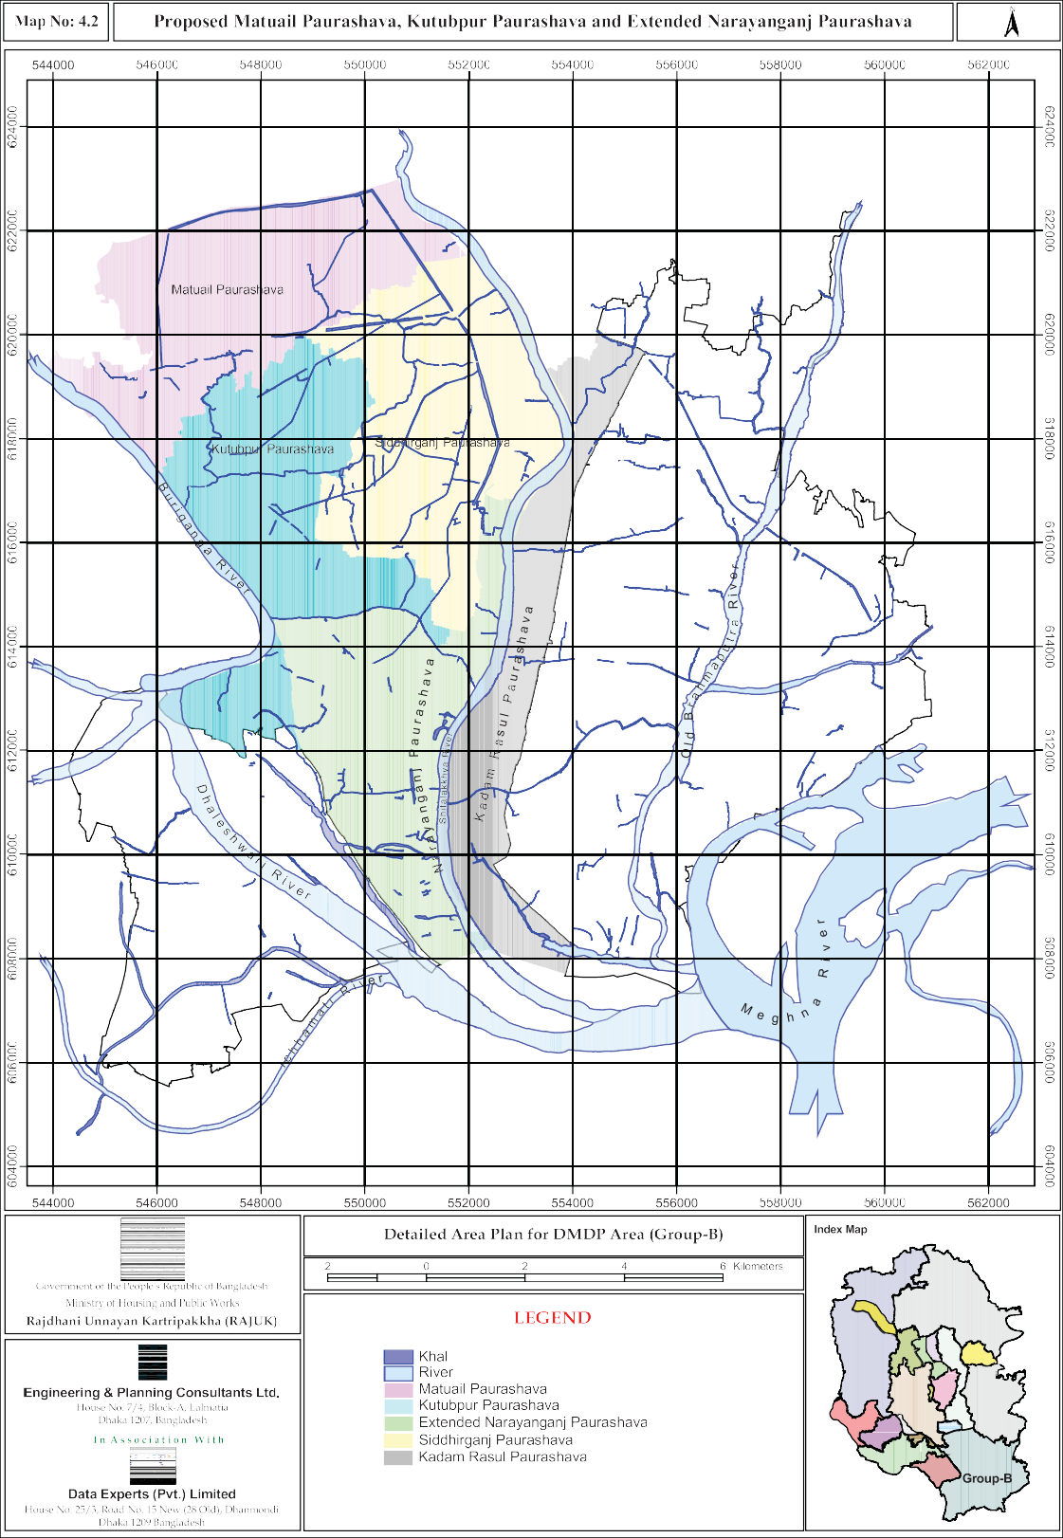

Chapter- 5 PROJECT PLANS

Introduction

Detailed Area Plan proposals have made provisions for huge number of projects implementation of which would ensure its benefit for the people. Each of these projects requires detailed design and estimation prior to on ground execution. Thus, each proposal embodies a chain of interrelated projects. Although RAJUK is the custodian of the DAP, projects are responsibility of Line Agencies and Local Govt. Authorities.

Several road projects in the form of Bridges, Grade separated Crossings between national and regional highways, Easement of traffic at the Chashara crossing, Grade separation of regional traffic artery from local main roads etc. are some of the important projects proposed in the DAP. Roads and Highways Department (RHD) and National Bridge Authority are the implementers of these projects. A number of criss-cross main roads ranging from 20m to 30m to provide necessary connectivity once the area is fully developed constitute a huge set of projects too for RHD.

Canal network within DND with installation of Pump Stations is a huge project under Water Development Board (WDB).

Action Plans proposed to be undertaken through people’s participation at certain areas are themselves massive projects and when finalized each of them would give rise to many projects on their way to materialization.

Description of the Projects

Out of the many projects four projects have been selected and developed. These projects have been chosen from the wish list of the Stakeholders. The projects involve complex management and managerial skill to negotiate among the involved government agencies and one private trust organization and prepare BOT franchise document. It is a complex proposition but not impossible one. When realized, this will greatly enhance recreation facilities in the area as well as upgrade the aesthetic quality of project sites. The projects are.

    - Chandmari Civic Complex (Figure 5.1)
    - Development of Fort Complex (Figure 5.2)
    - Development of Charagope (Figure 5.3)
    - Jimkhana Theme Park (Figure 5.4)

Indication of Different Project Cost/Detailed Program
Project – I (Figure 5.1)
 | Name of the Project | : | Chandmari Civic Complex
 | Description of the Project | : | Develop Chandmari Area into a Civic Complex having World Standard facilities for Shooting Range, Swimming and other Indoor Facilities.  Programs Include:  - International Shooting  - Swimming Pool  - Indoor Games  - Multipurpose Hall

- Archive
- Auditorium
- Open Plaza
- Jogging Facilities
- Restaurant
 | Objective of the Project | : | Provide the area with a sport complex to produce skilled sportsmen and jogging facilities for the Narayanganj residents.
 | Implementation Authority | : | A management Board composed of the representatives from –  - Bangladesh Army  - Narayanganj Sports Association  - Narayanganj Paurashava
 | Feasibility Study | : | Feasibility Study was not carried out. However, considering the utility of such a facility it is understood that it will be feasible.
 | Project Cost | : | Cost was not estimated as it will be implemented on BOT basis.
 | Financing | : | BOT. The seed capital, if needed, will be provided by Narayanganj Paurashava.
 | Land Requirement | : | Land is already there. No new acquisition or purchase is required.
 | Impact Assessment | : | Institutional  The project management will strengthen institutional capability of the Management Board.  Income  On expiry of the BOT Franchise the complex will be able to run profitably with its own income.  Employment  About 150 new jobs will be created to run the complex  Socio-economic  The complex will produce positive socio-economic impact in the project area  Environment  The project will improve the Physical environment of the area
 | Duration | : | Long Term

 | Catchment Area | : | Narayanganj and adjoining area
 | Recommendation of DMDP(1995-2015) Five Year Plan, Annual Development Plan | : | Slum Up gradation(DMDP)
Project – II (Figure 5.2)
 | Name of the Project | : | Development of the Narayanganj Fort at .
 | Description of the project | : | Conservation and development of the Narayanganj Fort at in to a Tourist Spot.  Programs include:  - Conservation of Fort Structures  - Boating (with traditional boat)  - River Cruising  - Sound and Lighting Show  - Elephant Ride  - Horse Carriage  - Open and Breathing Space for Common People  - Puthipath (Manuscript Reading)  - Parking  - Display and Sales Center of Traditional Craft  - Archive and Museum  - Restaurant and Floating Cafe
 | Objective of the Project | : | Restoration of Historic Site and Heritage Property and Breathing and Recreation Space for town dwellers as well as tourist from home and abroad.
 | Implementation Authority | : | Narayanganj Paurashava in association with The Archaeology Department and Bangladesh Inland Water Transport Authority.
 | Feasibility Study | : | Feasibility Study was not carried out; however, considering the importance of restoration of heritage property the project will be feasible.
 | Project Cost | : | Cost has not been estimated as it will be implemented on BOT basis
 | Financing | : | BOT. Seed capital will come from Narayanganj Paurashava
 | Land Requirement | : | Land has to be secured by canceling lease and donation from Bangladesh Inland Water Transport Authority.
 | Impact Assessment | : | Institutional  The project management will strengthen institutional capability of the Narayanganj Paurashava.

Income

On expiry of BOT Franchise the complex will be able to run profitably with its own income.

Employment

About 100 new jobs will be created to run the complex.

Socio-economic

The complex will produce positive socio-economic impact on the area.

Environment

The project will improve the Physical environment of the area.
 | Duration | : | Long Term
 | Catchment Area | : | Narayanganj and adjoining district, Foreign Countries
 | Recommendation of DMDP (1995-2015) Five Year Plan, Annual Development Plan. | : | Included in the DMDP (1995-2015)
Project – III (Figure 5.3)
 | Name of the Project | : | Development of Charagope
 | Description of the Project | : | Development of Charagope into a Regional Level Aquatic Recreational Facility  Programs include:  - Aquatic Rides  - Restaurant  - Jute Museum  - Snorkeling Zone  - Health Zone  - Food Court  - Renovation and Incorporation of Existing Mosque  - Renovation and Incorporation of Existing Shops
 | Objective of the Project | : | Improvement of the dwindling environment of the Charagope area and develop it as an aquatic sport centre of regional importance.
 | Implementation Authority | : | A Management Board composed of the representatives from:  - Bangladesh Inland Water Transport Authority  - Bangladesh Railway  - Kumudini Welfare Trust of Bengal

 |  |  | 4. Narayanganj Paurashava
 | Feasibility Study | : | To be carried out
 | Project Cost | : | Project Cost has not been estimated as it will be implemented on BOT basis.
 | Financing | : | BOT. The seed capital will be provided by Narayanganj Paurashva.
 | Land Requirement |  | Land will be donated by  - Bangladesh Inland Water Transport Authority  - Bangladesh Railway  - Kumudini Welfare Trust of Bengal (equity participation).
 | Impact Assessment | : | Institutional  The project management will strengthen institutional capability of the Management Board.  Income  On expiry of the BOT Franchise the complex will be able to run profitably with its own income.  Employment  About 120 new jobs will be created to run the complex.  Socio-conomic  The complex will produce positive socio-economic impact on the project area.  Environment  The project will improve the physical environment of the area.
 | Duration | : | Long Term
 | Catchment Area | : | Narayanganj and adjoining districts
 | Recommendation of DMDP (1995-2015), Five Year Plan, Annual Development Plan | : | DMDP (Augmentation of Open Space and Recreation Area from Public Land).
Project – IV (Figure 5.4)
 | Name of the Project | : | Jimkhana Theme Park
 | Description of the Project | : | Develop the Jimkhana Railway Colony, Jimkhana  Play Ground (Alauddin Khan Football Stadium) and adjacent low lying areas into a City level Theme Park

for recreational facilities of the people of Narayanganj City.

Programs Include:

- Rickshaw dropping and pedestrian entry
- Vehicular entry
- Parking (linked to each other at below grade)
- Pedestrian Circulation
- Curve Waterfront (Facilitating walking along and also informal seating by the water
- Children's Park
- Pleasant Rides
- Boating Facility (Paddle/oar driven)
- Planter slots
- Major Road (over passing uninterrupted park facility on viaducts)
- Pedestrian bridge (Connecting island)
- Heritage Shopping Mall (with traditional items)
- Sports facilities
- Restaurant and snacks facility
- Future expansion of park facilities & rides (if land could be secured)
 | Objective of the Project | : | - Provide the city with recreational facilities for all age groups of people.  - Improve the present degraded environment.  - Save the the valuable land from land grabbers and then improve the area as an open space cum retention area of rainfall runoff.  - Improve the functional character of the area.
 | Implementation Authority | : | Narayanganj Paurashava in association with Bangladesh Railway.
 | Feasibility Study | : | Feasibility Study has not been carried out. It is a project of civic necessity. As such its positive social impact outweighs any adverse financial effect, though it is expected that it will be financially viable too.
 | Project Cost | : | Cost has not been estimated as it will be implemented on BOT basis.
 | Financing | : | BOT. The seed capital, if needed, will be provided by Narayanganj Paurashava.
 | Land Requirement | : | The proposed Project site is now abandoned railway property and the adjoining low lying ditch area. No additional land required.
 | Impact Assessment | : | Institutional  The project management will strengthen managerial skill of Narayanganj Paurashava and bring back its old glory as best run municipality of whole of Bengal. It will usher a new era of joint venture and co-  operation between two public sector institutions along

with private investment. Income
On expiry of the BOT Franchise the income will be equally divided between Narayanganj Paurashava and Bangladesh Railway. Income is expected to be good enough for sustenance of a project of this magnitude.

Employment

About 200 new jobs will be created through this project

Socio-economic

The project will greatly improve the social environment as well as standard of the city.

Environment

The project will impact very positively on the physical environment of the site and transform it from the present dilapidated condition to a place of pleasing environment.
 | Duration | : | Long Term
 | Catchment Area | : | Narayanganj City and its adjoining areas.
 | Recommendation of DMDP(1995-2015) Five Year Plan, Annual Development Plan | : | Create, restore and renew open space (DMDP).

Design Aspects of the Projects

Preliminary designs of the projects have been made to give an idea about facilities to be provided in each of the projects. These are very preliminary design and needs thorough study which is beyond the scope of the present project. The following pages deal with the designs encompassing the overall idea of the facilities to be incorporated in these projects.

