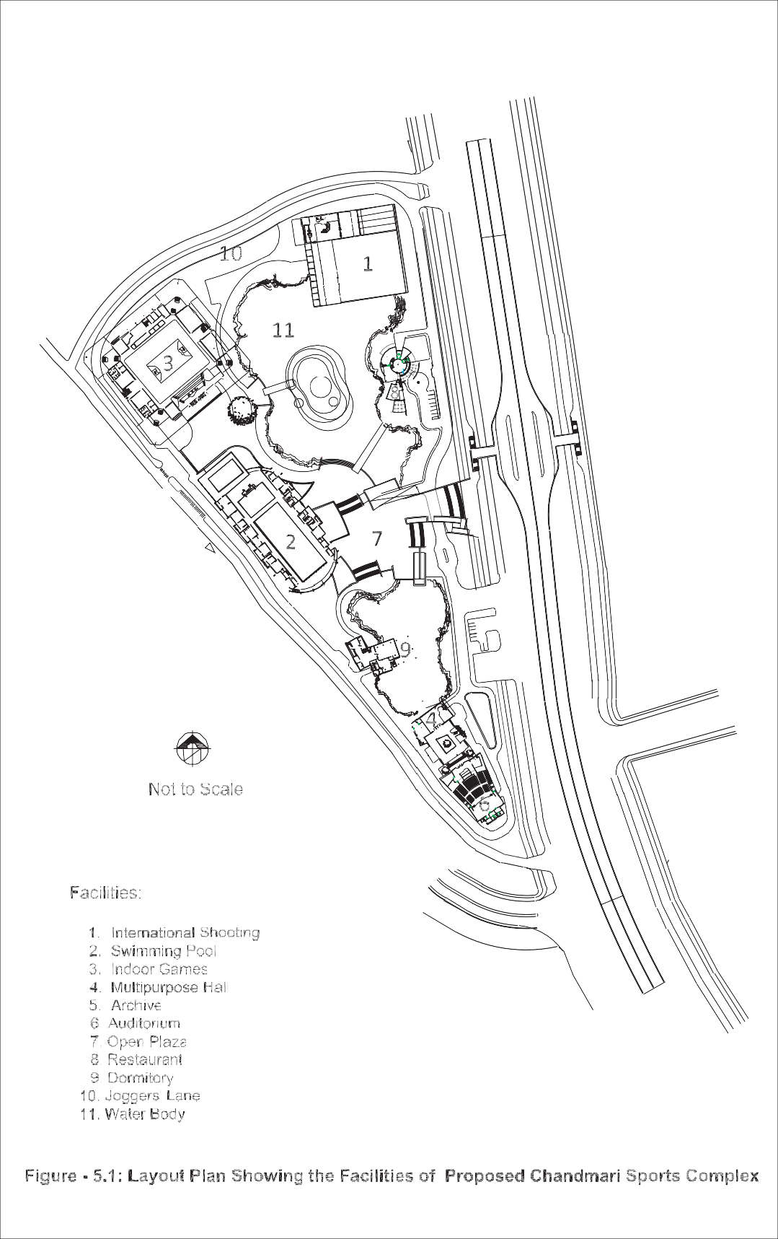

5

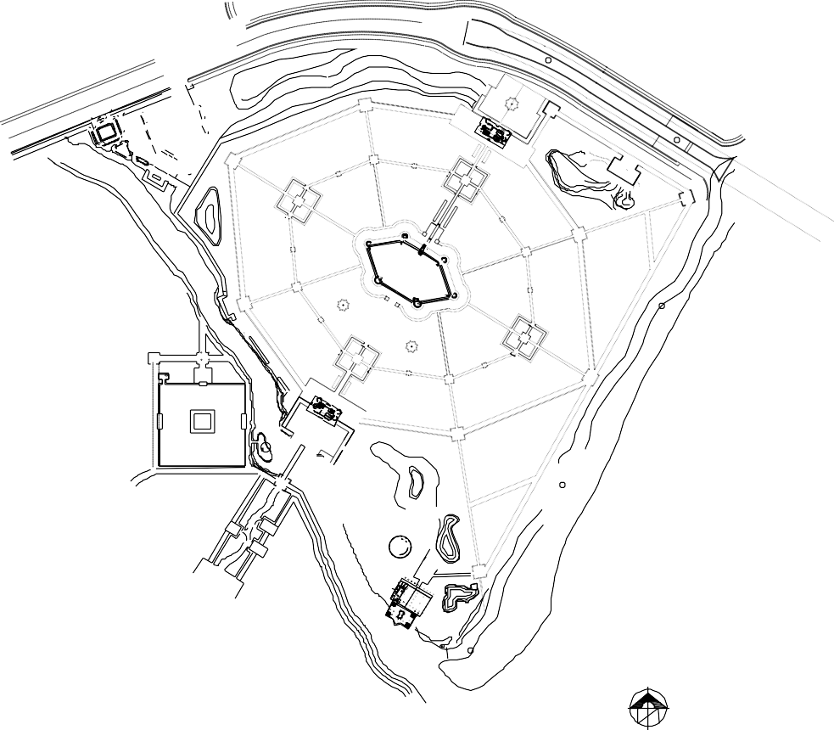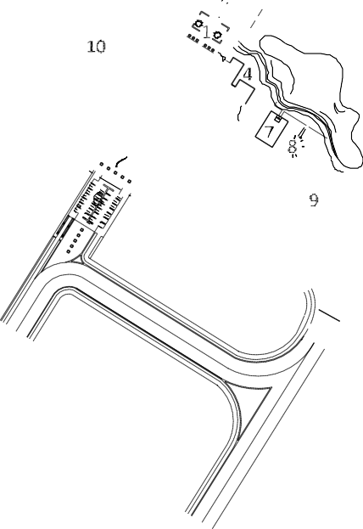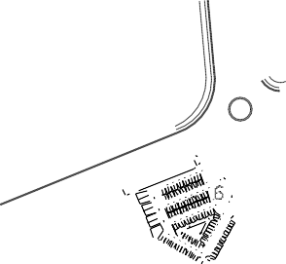

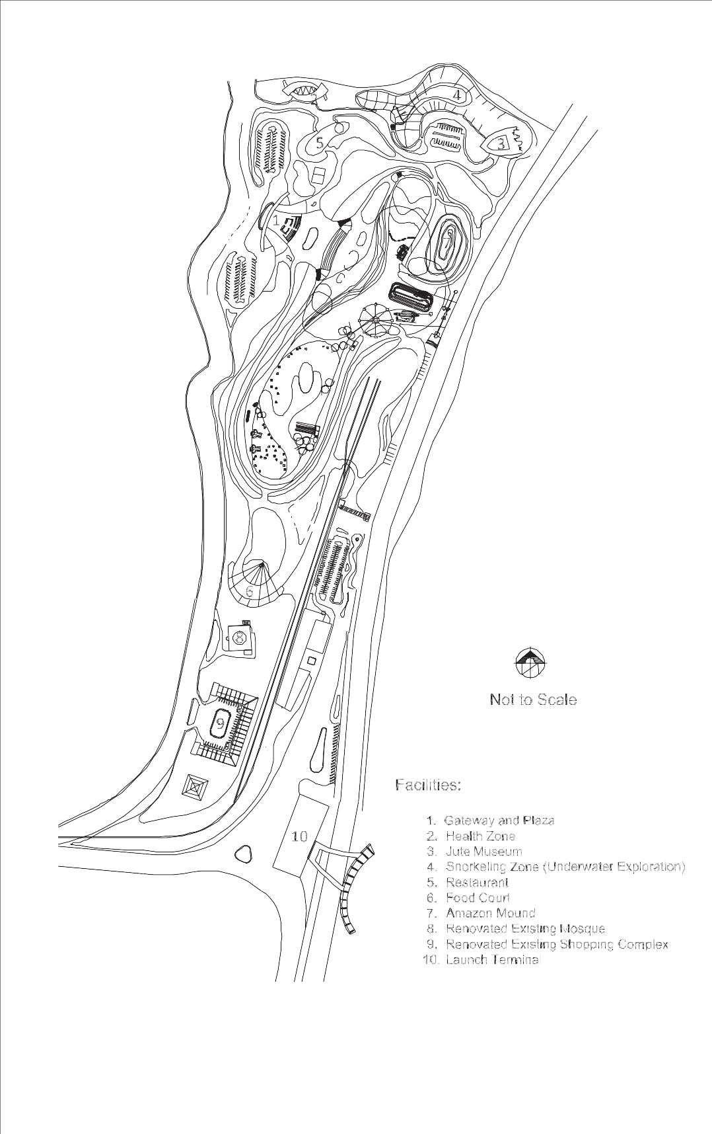

Figure - 5.3: Layout Plan Showing the Facilities of Aquatic Recreational Complex at Charargope

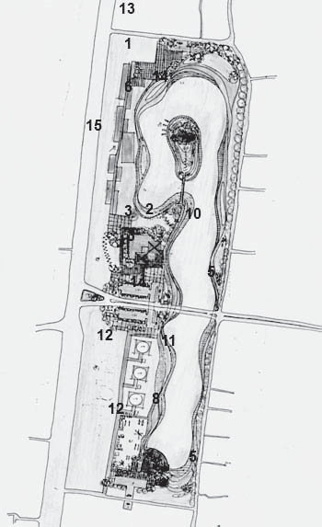
Facilities:

- Rickshaw dropping and pedestrian entry
- Vehicular entry
- Parking (linked to each other at below grade)
- Pedestrian Circulation
- Curve Waterfront (Facilitating walking along and also informal seating by the water
- Children's Park
- Pleasant Rides
- Boating Facility (Paddle/oar driven)
- Planter slots
- Major Road (over passing uninterrupted park facility on viaducts)
- Pedestrian bridge (Connecting island)
- Heritage Shopping Mall (with traditional items)
- Sports facilities
- Restaurant and snacks facility
- Future expansion of park facilities & rides (if land could be secured)
Figure - 5.4: Layout Plan Showing the Facilities of Proposed Theme Park at Jimkhana

