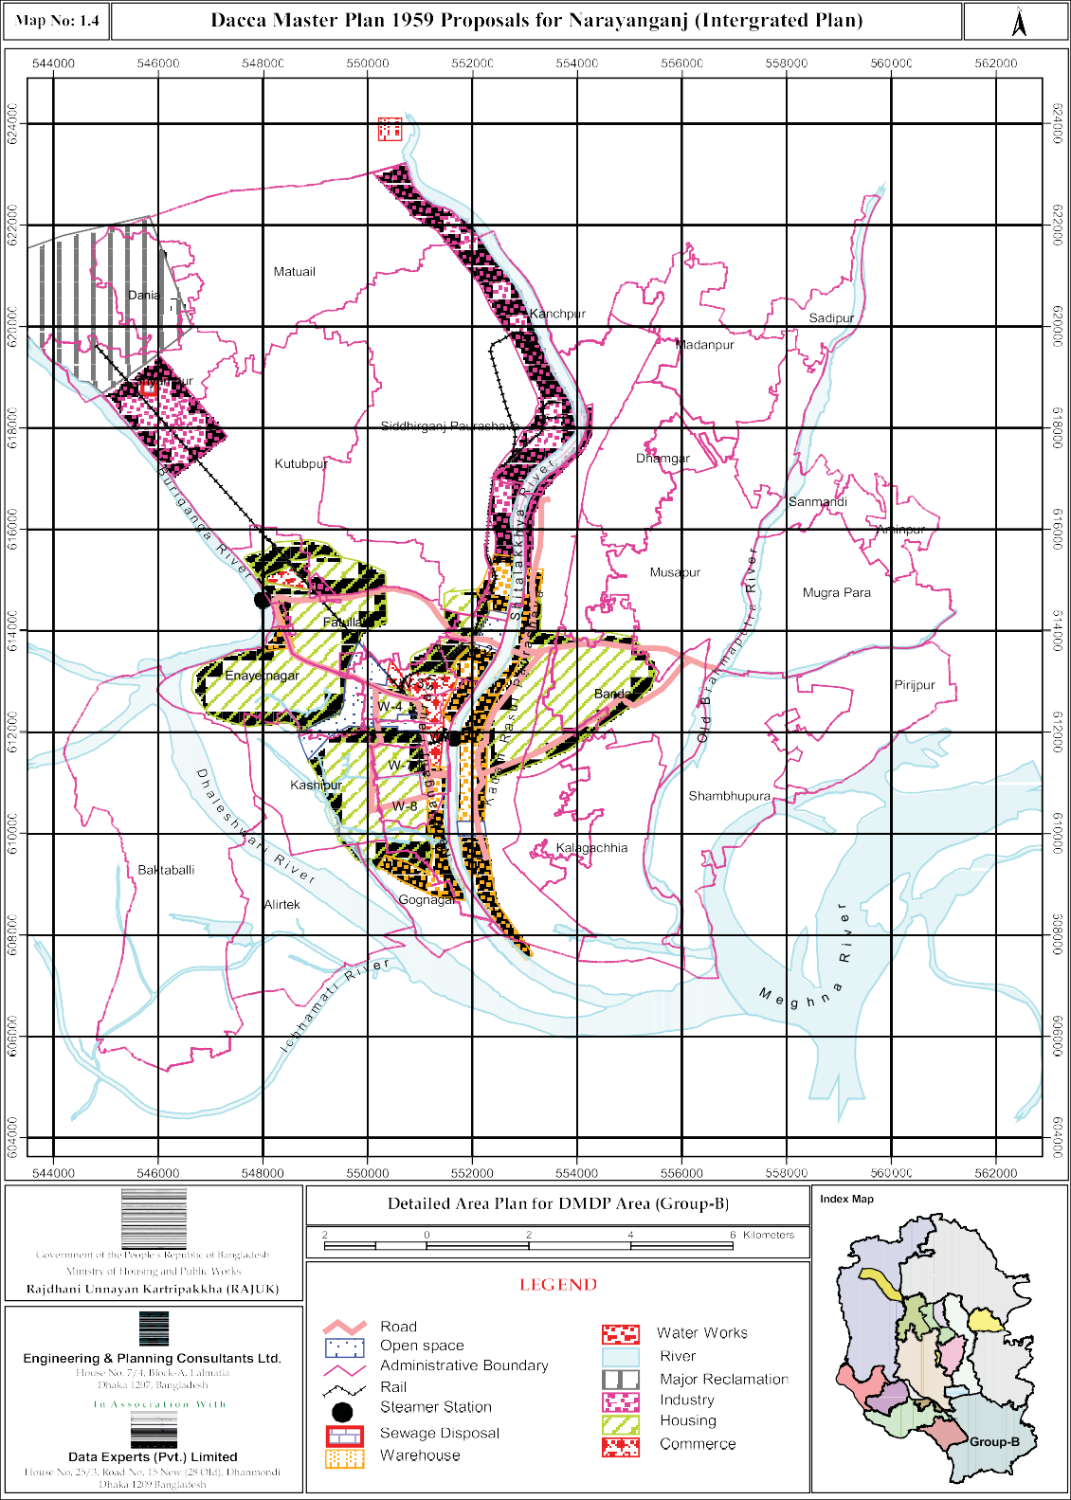

    - Dhaka Metropolitan Area Integrated Urban Development Project (DMAIUDP)

Relevant Recommendations
Dhaka Metropolitan Area Integrated Urban Development Project (DMAIUDP) was undertaken to develop a long term urban development strategy to guide and regulate the future growth of the Dhaka Metropolitan area. It aimed to set out appropriate policies designated to implement the proposed strategies and to prepare prototype proposals for low-income housing projects. The project also tried to offer advice on the establishment of effective planning and development organizations and to develop skills and experience of local staff. The major thrust of the strategy was for northern expansion of Metro-Dhaka and suggested creation of a buffer in the form of green belt between Metro-Dhaka and Narayanganj.

Application of DMAIUDP
DND experienced massive development though it was a preferred location for a buffer zone in the form of a green belt between Metro-Dhaka and Narayanganj.

DMAIUDP recommended higher standard of flood protection in DND, if development was to be carried out in massive scale. As flood protection standard was not improved, the area is suffering from protracted water logging causing immense miseries to the inhabitants.

New areas in the west of Narayanganj Paurashava came under urbanization as indicated, characterized by unplanned sprawl development with ill drawn road network and without adequate utility provisions.

The industrial area extended into DND and in the western end of Narayanganj Paurashava along the Panchabati- Mukterpur Bridge Road, ignoring the scope of containing it in the existing Narayanganj-Kadam Rasul industrial area on the both banks of the Sitalakhya river.

Development remained slow in the Kadam Rasul Paurashava area in spite of DMAIUDP prediction of urban growth between the Sitalakhya river and the railway track in the eastern end.

DMAIUDP never became a legal document as it was not adopted through enactment. Moreover, RAJUK could not apply it for development control function as the planning proposals were not drawn on mauza base.

DMDP Structure Plan and Urban Area Plan

The Dhaka Metropolitan Development Plan in the form of the Structure Plan and the Urban Area Plan was prepared during 1992-1995 to provide policy guidelines for the development of Metro-Dhaka for the period 1995-2015. The policies and strategies adopted in the plan was to provide a rough development control guideline for the Metro-Dhaka until the preparation of the Detailed Area Plan, the third of the three tier new urban development plan document. The Structure Plan and the Urban Area Plan framework relevant to Group-B area is presented below following the ToR guidelines-

Relevant Recommendations
The Structure Plan Landuse Development and Control Policies divide the Group-B area into following Landuse zones (Map No.1.5).

  - Established Urban Area up to 1989 (Consolidation)
  - New Urban Land Development Areas (Promotion)
  - Peripheral Urban Development (Enablement)
  - Urban Fringe Area
  - Agriculture Area
  - Main Flood Flow Zone
  - Sub-flood Flow Zone
  - Flood Retention Pond (Indicative)

About 40 percent of the Group-B area is covered by the Dhaka Urban Area development and development control proposals. The proposed landuse zoning in the Urban Area Plan has been derived from the policy guidelines of the Structure Plan. The landuse proposals in the Urban Area Plan includes following zones (Map No.1.6).

  - Existing Mixed Use Spontaneous Zone
  - Industrial Moderate Hazard Zone
  - Proposed Mixed Use Planned Zone
  - Proposed Mixed Use Spontaneous Zone
  - Water Supply Protection Zone
  - Restricted Flood Retention Reserves

Application of the Structure Plan and the Urban Area Plan
A considerable time has passed since the DMDP Structure Plan and Urban Area Plan were enacted. As predicted, areas other than the DND area in Group-B are experiencing slow growth pressure. In the DND area, water logging problem caused by haphazard spontaneous growth has slowed down the growth rate. However, large scale transfer of land is taking place resulting in the sub-division of the area into small fragments with provision of very narrow access roads. In some areas, industrial growth has taken place. Total disregard to controlled discharge of hazardous industrial effluent especially by the emerging dyeing industry has resulted in large scale water pollution. In the absence of strong and effective development control measures the area is developing in a completely haphazard manner and every year new areas are being occupied by settlements with little or no infrastructure or utility facilities.

