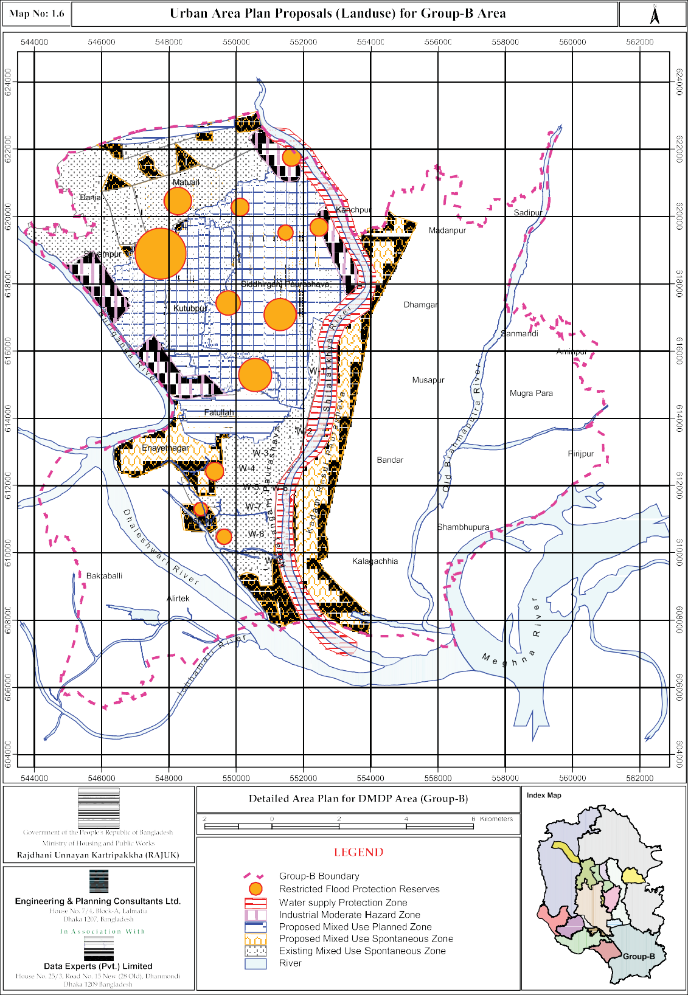

Public Consultation

Public consultation is an essential element of modern planning. Public consultation helps to get the pulse about the aspirations of the stakeholders regarding spatial development. In order to prepare the Plan in line with the desire of the people several formal and informal meetings were arranged with the stakeholders. In the initial stage stakeholders were apprised about the techniques of the plan preparation process and in the later stage, discussions were made about the draft plan.

Consultation with Local Government Authorities

Consultation meetings with all the government authorities within the group boundary were conducted separately. Due to the variation in the stages of development as well as nature of prime economic activities in the area, quite understandably hope and aspiration varied sharply among the authorities.

Public Consultation Meeting at Bandar Upazila
The consultants of Group-B arranged a public consultation meeting in Bandar upazila on September 25, 2005 to make the general people & other stakeholders aware about the purpose and process of the preparation of the Detailed Area Plan. Advocate Abul Kalam, Member of Parliament, Narayanganj-5 was the chief guest and Mr. Md. Nasir Uddin, Member Planning, RAJUK was the special guest of that meeting. Welcome speech was given by Mr. M.A. Kabir Mia, Project Manager, Group-B. Mrs. Nayeema Khatun, Project Director of DAP made a brief account of the aims and objectives of the Detailed Area Plan to the audience. Team leader Planner Al Ameen narrated the technical aspects of the plan preparation process by multi-media presentation. Mr. Ali Hossain, Upazila Nirbahi Officer of Bandar upazila presided over the meeting. Other participants in the meeting were Union Parishad Chairmen and members of their respective jurisdiction, representatives of public agencies, officer and staff of the Kadam Rasul Paursahava and the general people.

Public Consultation Meeting at Narayanganj Sadar Upazila
The public consultation meeting in Narayanganj Sadar upazila was held on September 27, 2005 to make the general people & other stakeholders aware about the purpose and process of Planning. Mr. Mohammad Gias Uddin, Member of Parliament, Narayanganj-4 was the chief guest and Mr. Md. Nasir Uddin, Member Planning, RAJUK was the special guest. Welcome speech was given by Mr. M.A. Kabir Mia, Project Manager, Group-B. Ms. Nayeema Khatun, Project Director of DAP made a brief account of the aims and objectives of the Detailed Area Plan to the audience. Team leader Planner Al Ameen narrated the Detailed Area Plan preparation process to the audience using multi-media presentation technique. Mr. Fayez Ahmed, Upazila Nirbahi Officer of Narayanganj Sadar upazila presided over the meeting. Other participants in the meeting were Union Parishad Chairmen and members of their respective jurisdiction, representatives of public agencies and the general people.

Public Consultation Meeting at Narayanganj Paurashava
The consultants of Group-B arranged a public consultation meeting separately in Narayanganj Paurashava on March 20, 2006 to make aware the Paurashava officials about the DAP. Dr. Selina Hayat Ivy, Chairman of Narayanganj Paurashava was the chief guest and Mr. Md. Nasir Uddin, Member Planning; RAJUK attended the meeting as special guest. Welcome speech was given by Mr. M.A. Kabir Mia, Project Manager of Group-B. Ms. Nayeema Khatun, Project Director of DAP gave a brief account of the aims and objectives of the Detailed Area Plan project to the audience. Team Leader Planner Al Ameen explained to the audience by multi-media presentation about the Detailed Area Plan preparation process. Other participants in the meeting were the Ward Commissioners and Officials of the Narayanganj Paurashava.

Public Consultation Meeting at Siddhirganj Paurashava
The consultants of Group-B arranged a public consultation meeting separately in the Office of the Siddhirganj Paurashava on December 6, 2006 to make aware the Paurashava officials about the DAP. Mr. Abdul Matin Pradhan, Administrator, Siddhirganj Paurashava was the chief guest. Team Leader Planner Al Ameen explained to the Administrator and the Councilors of the Paurashava about the Detailed Area Plan preparation process. Mr. Pradhan, Administrator of the

Paurashava in his comments briefly outlined his wish-list to develop this newly formed Paurashava with modern urban facilities. Other participants in the meeting were the Ward Commissioners and the Officials of the Paurashava.

Consultation With Different Communities

To feel the hopes and aspirations of the local community, different citizen bodies and CBOs, even individuals were directly contacted.

Public Consultation Meeting at Adarsha Chashhara
The Consultants of Group-B arranged a public consultation meeting at the residence of Mr. Anwaruddin Khan of Adarsha Chashhara Community around the Narayanganj District Administration Complex. Team leader Planner Al Ameen explained to the members of the community about the plan and the development technique through people’s participation. The representatives of the community showed interest in the plan and the development technique and made queries about different aspects of the technique and its implication. Mr. Wahidul Islam, Mr. Md. Shahjahan, Mr. Manir Hossain, Mr. Abdur Rahman, Mr. Anwaruddin Khan, Mr. Pear Mohammad and Prof. Md. Mafizul Haque took part in the discussion.

Public Consultation Meeting with Narayanganj Zila Unnayan Sangram Parishad
The consultants of Group-B arranged a public consultation meeting with the members of the Narayanganj Zila Unnayan Sangaram Parishad at their Office in the 2nd Floor of D.I.T.Market-2 of Narayanganj on December 20, 2008. The members of the association forwarded a tall list of projects they wanted to see included in the plan package. The projects that were of interest to DAP team were improvement of road network, setting up of open space, preservation of heritage properties, setting up of a University and Medical College in Narayanganj. Advocate Md. Saukat Ali, Mr.Khawja Mohiuddin, Mr. Mohar Ali, Mr. Delwar Hossain Chunnu, Mr. Abdus Sattar and Mr. Nurul Haque took part in the discussion and handed over their wish list in written form to the Team Leader Planner Al Ameen.

Public Consultation Meeting with the Tushar Dhara Housing Society, DND and Others
The Consultant team met with the members of the Tushar Dhara Housing several times. The members of the housing apprised the consultants about the water logging problem of the area. They suggested that the canals of the area to be re- excavated for retention and free flow of water. In addition the Consultants arranged several meetings with the members of the public as well as government agencies responsible for development activities in the area.

Public Hearing

As per section 74 of Town Improvement (TI) Act 1953, RAJUK carried out a two month long Public Hearing on the Detailed Area Plan from October 3, 2008 to December 4, 2008. The Public Hearing was carried out through:

- Media Coverage
  - Print
- Electronic
- Press Conference
- Web based Publication
- Display of Maps (Hard Copy)
  - RAJUK Auditorium
  - DAP, PD Office
  - RAJUK Zonal Office at Dhanmandi
  - RAJUK Zonal Office at Mohakhali
  - RAJUK Zonal Office at Uttara
- Explain different aspects of the Plan to the stakeholders by experts
- Mauza Plot level digital display in GIS Platform
- Collection of Complaints in prescribed format and preparation of checklist
- Collection of Complaints in the form of letter to Chairman/P.D.

A total of 6506 complaints/comments were made on the plans by the stakeholders of Group-B area. Complaints were received from individuals, groups, institutions/organizations, local co-operatives and Private Developers. Most of the complaints were related to proposed road network. For fear of eviction, the land owners of the plots over which new roads have been proposed have made complaints in a very large number. However, quite a good number of people also appreciated the plan and wanted its early implementation.

Number of Complaints/Comments
Out of 6506 complaints/comments, 2244 complaints were made against the proposed north-south and east-west major roads. The proposed DMDP and STP recommended 300’ wide DND spine road from Chashara, Narayanganj to Tongi through the centre of DND was opposed by 2718 persons individually or in group. Other fields of complains were landuse, widening of canals, fear of eviction etc. A total of 649 persons appreciated the plan. Here it may be mentioned that, this is a very tiny number in comparison to the actual number of people enquiring about the plan. Most of the people went away satisfied without lodging any comments. The types of complains and their number is shown in the following figure.
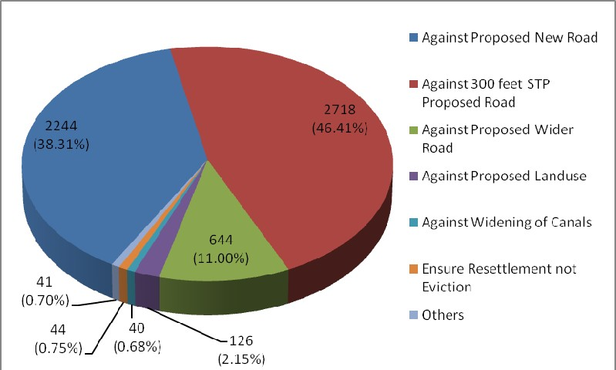

Figure - 1.1: Complaints from Different Stakeholders (Excluding Appreciation)

Types of Stakeholders
Comments/complains were received from individual, group, Developers, institutions/organizations and local co-operatives. More than 98 percent complains were made by individuals. Following Figure shows the types of complainants
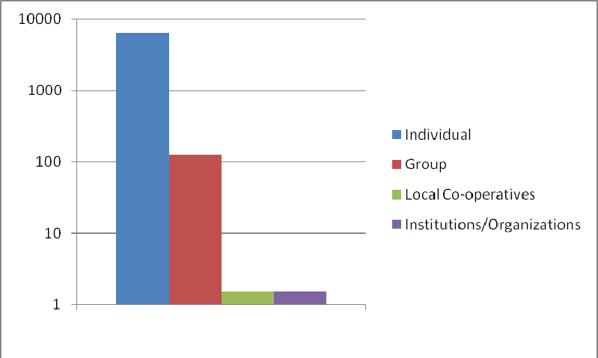

Figure - 1.2: Types of Stakeholders

Follow up Action
All the comments/complaints have been listed, analyzed and examined whether they could be attended. It was found that the affected people out of fear of eviction made complain against proposed roads. On the other hand, road proposals have been made after thorough assessment of future trip generations and space requirement for their construction. DND area is a drainage problem area. Attempts have been made to address the problem through widening of the existing canals and connecting the gaps. As a result complaints against canals also could not be addressed. However, in most cases complaints against landuse proposals have been attended.

Following Table represents a Summary of responses received on Public Consultation and Actions Taken

Table - 1.8: Complaints from Different Stakeholders and Actions Taken
 | Type |  |  |  | Total | Total Complains Addressed | Total Complains Unable to Address | Remarks
 | Individ ual | Group | Local Co- operativ  es | Instituti ons/Org anizatio  ns
Against 300 feet STP proposed road | 2714 | 4 | --- | --- | 2718 | --- | 2718 | See Note
Against proposed new road | 2159 | 84 | --- | 1 | 2244 | --- | Partial Compliance | See Note
Widening of existing roads  instead of proposed wider roads | 626 | 17 | 1 |  | 644 | --- | Partial Compliance | See Note
Against proposed landuse | 115 | 11 | --- | --- | 126 | 97 | Partial Compliance | See Note
Ensure resettlement not eviction | 42 | 2 | --- | --- | 44 | --- | 44 | See Note
Against widening of canals | 38 | 2 | --- | --- | 40 | 12 | 28 | See Note
Others | 37 | 4 | --- | --- | 41 | --- | 41 | See Note
Total | 5731 | 124 | 1 | 1 | 5857 | --- | --- | See Note
Appreciation | 649 | --- | --- | --- | 649 | --- | --- | See Note
Grand Total | 6380 | 124 | 1 | 1 | 6506 | 109 | --- | See Note
Source: Compiled from Public Hearing Record Books

Note: Complains have been made from the fear of eviction as traditionally in our country these types of development activities are carried out through compulsory land acquisition. But land acquisition can be avoided by involving land owners in the development process. In the process land owners become partner in the project and contribute land voluntarily to secure right of ways for roads and civic amenities. Such projects are to be taken on areal basis. All the aspects of an area are taken into consideration and plots are re-plotted according to an agreed plan. Land owners get back their plots after proportionate deduction of land for roads and other uses. This way the land owners get a fully serviced plot and their land value enhances and become easy to use. On the other hand the development authority implements the plan with no cost from public fund other than the seed capital needed for the kick start of the project.

In our country for resource constraints large scale development projects cannot be under-taken in time. As a result, sprawl development takes place making our urban areas haphazard and without proper circulation system and utility provision. In order to avoid this it is essential to implement these projects before unplanned developments take place. This can only be possible, if people are involved in the development process as equity partner. If land development projects are under- taken using techniques which include land owners, there shall be no such complaints.

Besides Public Hearing group discussions were held with following organizations:

  - Local Government Authority
Narayaganj District Administration, Narayanganj Paurashava, Kadum Rasul Paurashava, Siddhirganj Paurashava, concerned Union Parishad
  - Academics
Department of Urban and Regional Planning of BUET, JU and Department of Urban and Rural Planning of KU
  - Professional body
Bangladesh Institute of Planners, Institute of Architects Bangladesh
  - Study groups
Center for Urban Studies
  - Business group
FBCCI, DCCI, REHAB, BLDA, Dhaka Mohanagar Samity
  - Media
The Daily Inqilab, The Daily Naya Diganta, The Daily Sambad

Outcome of the Group Discussion
Opinions of the group discussions are:

- DCC Mayor advised to prepare Plans for 50-100 years
- Academics demanded protection of Flood Flow Zones at any cost, protection of agriculture area, separation of rural homestead from agriculture
- DCCI appreciated the treatment of industrial use
- Dhaka Samity demanded no intervention of their cultural practice; when the central jail would be relocated, develop the area as their breathing space; and establishment of a road link with Old Dhaka through BDR
- Paurashavas wanted to uphold their legal development control right in the form of issuance of Planning Permit
- Affected People did not want wider roads and civic facilities which evict them from their land without resettlement.

Consultation with Public Representatives

A series of consultation meetings were held with the Honorable Members of the Parliament of the RAJUK jurisdiction area to apprise them of the draft final DAP and obtain their valuable suggestions and recommendations. Almost whole August and half of September, 2009 was spent on this consultation. The outcome of the consultations may be summarized as follows:

Honorable members appreciated the endeavor and expressed that in order to develop Dhaka in a planned way all necessary measures including implementation of the draft DAP should immediately be under-taken.

Specific suggestions for widening of certain roads and creating new connectivity were made by them. Honourable members also suggested changes in the Landuse proposals. The Consultants accommodated their suggestion where higher level plan allowed. Suggestions that did not conform to the higher level plan could not be adhered to.

Draft DAP Review by Review Committee

A Review Committee (RC) to review the Draft Final Plan submitted by the Consultants was formed by the Ministry of Housing & Public Works with Prof. Dr. Jamilur Reza Chowdhury, Vice Chancellor, BRAC University as convener. In order to assist the Review Committee in the task, a 16 member Technical Working Group (TWG) was formed with members from Urban and Regional Planning Department of BUET, Urban and Regional Planning Department of JU, Bangladesh Institute of Planners, Institute of Architects Bangladesh, Urban Study Group and RAJUK. Following issues proposed by the Consultants were of concern of the RC and TWG.

- Population
- Rural Homestead Zone
- Flood Flow Zones
- Agricultural Zone
- Retention Pond & Canal
- Road Network
- Urban Deferred
- Standards
- Existing Non Complied Uses

On the recommendation of TWG, the Review Committee (RC) finalized their report on March 30, 2009. But the consultants were of different opinion about it and it was decided to resolve the issue through discussions among the RC, RAJUK and the Consultants. Accordingly a series of tripartite meetings were arranged and finally the matter was resolved through consensus reached by all the three parties. According to consensus following decisions were made.

- Population
  - Population for 2015 shall be projected on the basis of:
    - Population of 2001 shall be considered as 10.24 Million.
    - Population for 2015 shall be accepted as 18.43 Million.
    - Overall Annual Growth Rate shall be considered as 4.29 %.

- Rural Settlement Zone
  - A new zone namely Rural Settlement Zone was created to accommodate and confine traditional rural settlements and rural growth centers.

- Flood Flow Zones
  - Since all the structures have been contained within newly created Rural Settlement Zone, the remaining parts of Main Flood Flow and Sub Flood Flow zone become one and therefore merged into one zone only, namely Flood Flow Zone.

- Agricultural Zone
  - High value Agricultural Zone and Agricultural Zone shall be merged into one zone namely Agricultural Zone due to their uniform and similar landuse control requirement.
  - Any further use that does not conform to the Agricultural Zone shall be strictly prohibited.

- Retention Ponds & Canals
  - Retention Pond as provided by the Consultants in the form of canals at DND and the Eastern Fringe may be maintained as they comply with the Structure Plan & Urban Area Plan.
  - Retention Pond as provided by the Consultants at the outskirts of the Eastern Fringe alongside the embankment to ease pumping out of water may be maintained.
  - Canal Network at the Eastern Fringe may be improved by creating links among them.
  - Canals for drainage of Eastern Fringe as per Halcrow Study will work but FAP 8A proposed Retention Area may be kept as further caution.
-
- Road Network
  - Grid Iron pattern for main roads (Down to secondary roads) as proposed by the Consultants may be provided.
  - Crossing the canals by main roads (Down to secondary roads) as proposed by the Consultants may be provided.
  - Regional Road over Retention Pond on viaduct may be provided.

- Urban Deferred
  - Since DAP projected population for 2015 is more than the estimated population of the Structure Plan, no part of the area designated as urban in the Structure Plan is required to be shown as urban deferred.

- Standards
  - Amenity Standards as set by the DAP Consultants are acceptable.
  - Standard of Regional Parks and Open Spaces within DMDP will be 0.28 acres /1000 people.
  - Spaces for the Universities to be earmarked in suitable locations within DMDP jurisdiction.

- Existing Non Complied Uses
  - The use/function that do not comply with the designated landuse category shall be either of the following types:
    - Overlay Zone: Non-complied use/function that DAP allows to continue in its present use.
    - Non-conforming Use/Site: Non-complied use/function that DAP does not allow to continue in its present use and fixes time frame for its discontinuation based on the nature and extent of its potential adverse effect on the underlying landuse.

  - Non conforming uses/function may be described as follows:
    - RAJUK’S Own Project
    - Facilities Owned by Government/Semi-government and/or Autonomous Body.
    - Private Projects.

Draft DAP Review by DAP Porjalochana Committee

Ministry of Housing and Public Works vide a notice no. Gri o pu ma/Pari-3/1(5)/2001(Part-3)43 dated 7-3-2010 constituted a DAP Porjalochana Committee with the following members to verify the compliance status of the recommendations made by the previous Review Committee according to a ToR.

- Prof. Dr. Jamilur Reza Chowdhury : Convener Former VC, BRAC University
- Prof. Nazrul Islam, Chairman : Member University Grants Commission
- Prof. Dr. Sarwar Jahan, President : Member Bangladesh Institute of Planners
- Ms. Rezwana Hasan : Member Chief Executive Director, BELA
- Architect Iqbal Habib : Member Jt.Secretary, BAPA
- Project Director, Detailed Area Plan : Member Secretary RAJUK, Dhaka.

The committee reviewed the status of the Draft DAP in view of the recommendations of the previous Review Committee in four separate meetings held on 16-03-2010, 25-03-2010, 01-04-2010 and 11-04-2010 in the RAJUK Board Room. The committee ultimately made 36 point recommendations to be followed by the consultants. The committee also recommended that on compliance of these recommendations made by the porjalochana Committee, the Draft DAP may be accepted by the ministry.

Chapter- 2 CRITICAL PLANNING ISSUES

Existing Development Pattern

General

Wide variation is found in the existing development pattern of the Group-B area. There is no planned residential area. Most of the settlements are mixed use zones. However dominant use in the mixed use zones is residential use excepting for some areas of Narayanganj Paurashava where commercial use dominates. Here it may be mentioned that the commercial dominated areas of Narayanganj Paurashava were zoned as commercial area in the Dacca Master Plan 1959. However, there are two industrial estates in the Group-B area. These are RAJUK sponsored Shyampur–Kadamtali Industrial Area in the DND triangle and BSCIC sponsored Hosiery Estate (knit garments) in the Panchabati area. A very large section of the area is rural in character and subject to annual flooding.

Socio-economic Profile

Socio–economic profile of the Group-B area has been revealed from the Socio-economic survey of households. Five percent households of the area were surveyed and following broad information has been gathered through it.

Family Size
The predominant family size in the Group-B area is 4-5 member family. The next important group is family with 6-7 members. These two groups together constitute about 58 percent families. This is a little higher than the national average, but is not unusual for an area dominated by industrial and commercial activities. Following Table No.2.1 presents the details of family size in the Group-B area as has been found from the socio-economic survey.

Table - 2.1: Family Size
Family Size | Number of Households | Percentage
1-3 | 3241 | 24.1
4-5 | 4554 | 33.9
6-7 | 3335 | 24.8
8-9 | 1925 | 14.3
10 & above | 383 | 2.9
Total | 13438 | 100
Source: Socio-economic Survey, 2005

Age and Sex Structure
It has been found that the Group-B area is a male dominated area which is 55 percent of the total population. This is almost similar to our national figure of 105 males per 100 females. However, the majority of the population belongs to 16- 40 age group. Details of age-sex variation in the population are provided in the following Table No. 2.2.

Table - 2.2: Age and Sex Structure
Age Distribution | Male | Percentage | Female | Percentage | Total Population | Percentage
Below 6 | 2749 | 5.1 | 1924 | 3.5 | 4673 | 8.62
6-15 | 7636 | 14.1 | 5727 | 10.6 | 13363 | 24.64

Age  Distribution | Male | Percentage | Female | Percentage | Total  Population | Percentage
16-24 | 5197 | 9.6 | 8032 | 14.8 | 13229 | 24.4
25-40 | 8211 | 15.1 | 5875 | 10.8 | 14086 | 25.98
41-60 | 5100 | 9.4 | 2431 | 4.5 | 7531 | 13.89
60+ | 944 | 1.7 | 402 | 0.7 | 1346 | 2.48
Total | 29837 | 55 | 24391 | 44.9 | 54228 | 100
Source: Socio-economic Survey, 2005

Religious Groups
Muslims represent 93 percent of the total population. It also has a sizeable percentage of population of other religious groups like Hindu (6.5 percent), Buddhist (0.2 percent) and Christian (0.2 percent). Buddhist community is found to live in the Narayanganj Paurashava, Siddhirganj Paurashava, Enayetnagar, Kutubpur and Shyampur areas. Christian people are found in Narayanganj, Siddhirganj Paurashava and Matuail union. Muslim and Hindu community people are distributed all over the area. Religion based distribution pattern of the population is provided in the following Table No. 2.3.

Table - 2.3: Religion
Religion | Number of Households | Percentage
Muslim | 12506 | 93.1
Hindu | 879 | 6.5
Buddhist | 27 | 0.2
Christian | 26 | 0.2
Total | 13438 | 100
Source: Socio-economic Survey, 2005

Educational Status
In the Group-B area, it is found that about 85 percent people have attained education level ranging from primary level to higher education. Out of the total sample population 8.4 percent never attended school and 7.20 percent are infants. Majority of the people of the area have attained junior level education and accounts for 27.9 percent. People with primary level, junior level, high school level education constitute 65.70 percent. About 1.50 percent people are reported to have attained religious education meaning Madrasha level education. Table No. 2.4 provides information on educational status of the Group-B area people.

Table - 2.4: Educational Status
Educational Status | Number of Persons | Percentage
Illiterate | 4561 | 8.4
Primary Level | 13105 | 24.2
Junior School | 15153 | 27.9
S.S.C. | 7380 | 13.6
H.S.C. | 4500 | 8.3
Bachelor Degree | 3184 | 5.9
Master Degree (incl.equivalent) and above | 1212 | 2.3
Vocational | 188 | 0.3
Technical (Diploma) | 208 | 0.4

Educational Status | Number of Persons | Percentage
Religious education | 833 | 1.5
Infant | 3904 | 7.2
Total | 54228 | 100
Source: Socio-economic Survey, 2005

Occupation/Employment Pattern
From the occupational pattern it is found that number of people engaged in the traditional agricultural sector is comparatively low. Land owning peasant and agricultural labor together constitute 1 percent of the total work force. Business is one of the main occupations of the people of the area which occupies 11.2 percent. Service in government/non-government organizations is the occupation of about 11 percent people. Household work indicating housewives is the largest group in the area. Employments in industries as skilled Mechanic/Artisan or unskilled workers comprise 3.2 percent. About 23 percent are students while unemployed constitute 6.2 percent. A substantial number, comprising 7.8 percent are infants. Occupational pattern of the area is presented in Table No. 2.5

Table - 2.5: Occupational Status
Occupational Status | Number of Persons | Percentage
Self Employed | 1068 | 2
Employed in Govt./semi govt. Institution | 1859 | 3.4
Employed in Private Organization | 4119 | 7.6
Business | 6100 | 11.2
N.G.O. Worker | 268 | 0.5
Rickshaw/Van puller | 245 | 0.5
Motorcar Driver | 298 | 0.6
Skilled Mechanic/artisan | 713 | 1.3
Industrial Worker | 1033 | 1.9
Day Labor (Non Agri) | 581 | 1.1
Land Owner peasant | 190 | 0.4
Day Labor (Agri) | 343 | 0.6
Household Worker | 15346 | 28.3
Unemployed | 3357 | 6.2
Students | 12472 | 23
Infant | 4236 | 7.8
Day Labor General | 587 | 1.1
Others (Mention) | 1413 | 2.5
Total | 54228 | 100
Source: Socio-economic Survey, 2005

Income and Expenditure Levels
Out of the total, more than 64.3 percent household have a monthly income of Tk.8000.00 or below. 16 percent households have income of less than Tk.3000.00 per month and may be classified as poor. The low income people with income ranging from Tk. 3001-5000 constitute 23.9 percent households. It is found that 8.9 percent of sample households have a monthly income of Tk. 20000+.

Table - 2.6: Level of Income
Level of Income | Number of Persons | Percentage
1-3000 | 2412 | 16.5
3001-5000 | 3483 | 23.9
5001-8000 | 3482 | 23.9
8001-12000 | 2352 | 16.1
12001-20000 | 1560 | 10.7
20000+ | 1297 | 8.9
Total | 14586 | 100
Source: Socio-economic Survey, 2005

From the survey it has been found that 24.7 percent people of the area spend Tk. 5000.00-Tk 8000.00 per month, 12.5 percent people spend Tk. 2001.00-3000.00 per month. Only 6.6 percent households have a monthly expenditure of above Tk. 12000.00. The expenditure table indicates that the population of the Group-B area has some savings. Table No. 2.7 illustrates the expenditure level and the percentages of various categories of monthly expenditure level.

Table - 2.7: Family Expenditure
Family Expenditure | Number of Households | Percentage
1-2000 | 1493 | 11.1
2001-3000 | 1676 | 12.5
3001-4000 | 1870 | 13.9
4001-5000 | 2342 | 17.4
5001-8000 | 3314 | 24.7
8001-12000 | 1859 | 13.8
12000+ | 884 | 6.6
Total | 13438 | 100
Source: Socio-economic Survey, 2005

Source of Income
Income from salary is the main source of income (38.7 percent) of the Group-B area people as per socio-economic survey. The next large source of income is derived from business (22.7 percent). A substantial number of people depend on income from rent (11.11 percent) and property. Lowest percentage belongs to owners of manufacturing units (1.2 percent) group. Wage earners constitute 6.3 percent and 3.6 percent live on agriculture, while 2 percent depend on Remittance. Following Table No.2.8 provides details of source of income of the Group-B area People.

Table - 2.8: Source of Income
Source of Income | Number of Persons | Percentage
Salary | 5643 | 38.7
Income from property | 1305 | 8.9
House/Flat rent | 1783 | 12.2
Business | 3305 | 22.7
Wages | 915 | 6.3
Agriculture | 528 | 3.6
Cottage industry/Handicrafts | 174 | 1.2

Source of Income | Number of Persons | Percentage
Remittance | 295 | 2
Others | 638 | 4.4
Total | 14586 | 100
Source: Socio-economic Survey-2005

Migration
The Group-B area is mostly inhabited by local people. Mostly in the urban section of the area, migration has taken place. As a result, it is found that 75 percent of the people are local while 25 percent people have migrated to the area mostly for employment.

Landuse

Residential Areas
Residential use of land has been classified as Urban Residential area for urbanized area and Rural Homestead for rural area. Total acreage under residential use has been found to be 11396.72 acres which is 22.50 percent of the total land area. DND part of the Demra thana area is almost built up and ranks highest in terms of area under residential use. It has 3035.53 acres which is 26.63 percent of the residential area indicating the growth pressure in the area. In the Siddhirganj Purashava area, the residential part is spread over a large area and covers 2942.97 acres which is 25.82 percent of the total land under residential use. Narayanganj paurashava residential use is found to cover 1201.06 acres of land which is
10.54 percent of the land under residential use (Map No. 2.1).

Rural Homestead (Rural Housing) occupies a total of 5315.57 acres which is 10.49 percent of total land area of Group-B. Musapur union ranks highest in this category of landuse indicating that this union is the most populous union of the rural areas with 1182.70 acres land, which is 22.25 percent of total land under Rural Homestead category. Other places with higher acreage under this category are Kalagachia Union (856.30 acres), Bandar Union (802.32 acres), Kadam Rasul Paurashava (797.17 acres), Mograpara Union (788.14 acres) and Dhamgar Union (654.97 acres)

Industrial Areas
Narayanganj area is one of the important industrial areas of the country. Quite a substantial number of industries are located here. However, the nature of industries that dominate the area requires lesser amount of land and space requirements are met through vertical expansion. This special characteristic tends to reduce acreages in the industrial sector which is 1700.25 acres or 3.35 percent of the total area. Narayanganj Paurashava area with 386.65 acres in industrial use ranks highest in this category of landuse. Siddhirganj Paurashava which houses the industrial zone located in the west bank of Sitalalhya river, ranks second with 312.39 acres in the manufacturing sector. It is followed by Demra part of the Group-B area (258.81 acres), Enayetnagar union (161.72 acres), Kutubpur union (138.12 acres) and Fatullah union (132.27 acres).

Commercial Areas
In the area commercial activities have been found to occupy 1193.79 acres of land which is about 2.35 percent of the total land. Demra thana area has the highest acreage amounting 316.60 acres in this category which indicate that the area is full of settlements. Other areas with higher acreage in commercial activity category are Siddhirganj Paurashava (227.45 acres), Narayanganj Paurashava (179.51 acres) and Kutubpur union (129.19 acres). Aminpur union ranks lowest with only 0.18 acre under commercial use (Map No.2.2).

Amenities and Urban Facilities
Amenities and Urban Facilities occupy 192.82 acres land and Siddhirganj Paurashava area (52.94 acres) has the highest amount of land in this category. In fact all the urban areas are found to have higher amount of land in this category compared to rural areas. Kutubpur union and Fatullah union are the other areas with higher acreage under the amenity and urban facility category of land. It has been found that in Narayanganj Paurashava 41.88 acre of land, in DND 43.57

acres, Kutubpur union 14.42 acres and Fatullah union 11.72 acres are in use under this category. A variety of uses like bank, health facilities, treatment plants, engineering workshops, hotel, restaurant, police station, fire brigade and like are included in this category of landuse.

Non urbanized Areas
Non urbanized areas are mostly areas with predominantly agricultural use and rural homestead areas. As description of rural homestead areas has already been provided in this section, an account of agricultural land is made as non urbanized areas. Total land under agricultural use is 11788.75 acres which is 23.27 percent of the total area. Baktabali, Shambhupura and Kalagachia unions rank high in terms of agricultural use of land. Other areas with higher amount of agricultural land are Alirtek, Musapur, Dhamgar, Pirizpur, Bandar and Mogra Para unions. These areas have distinct rural character.

Infrastructure
      - Circulation Network Road
The area is served by 1605.21 kilometers of roads. Total area covered by road network is about 1195 acres. Out of the total length of roads 504.81km are pucca, 221.80 km are semi-pucca and 882.76 km are Kutcha. Highest length of road network is found in the DND part of Demra thana area followed by Siddhirganj Paurashava. It is found that in the DND area of Demra thana out of 388 km roads, only 103 km are pucca. In Siddhirganj Paurashava out of 300.40 km of roads, 82 km roads are pucca. Alirtek union of Narayanganj Sadar Thana is without any pucca road. Out of total 69.60 km roads of Narayanganj Paurashava area road network, 50.95 km are pucca, 4.33 km are semi-pucca and 14.31 km are kutcha road. Road network in the Demra area covers 282.98 acres land, Siddhirganj Paurashava covers 207.82 acres and Narayanganj Paurashava 78.21 acres land. Kutubpur union and Fatullah union have 148 acres and 70 acres respectively under road network (Map No. 2.3).
National Highway no. 1 which connects Chittagong with Dhaka covers part of the Group-B area. In the DND part, it is named as Mukti Sarani. From the eastern part of the Kanchpur Bridge, it is known as Dhaka-Chittagong road. The Group- B area portion of the road extends up to eastern boundary of RAJUK jurisdiction area. Zila Roads connect different places of the Group-B area, urban road constitutes the circulation system of paurashava areas while rural roads serve the areas beyond the paurashava boundaries extending deep into the outlying rural areas.

Regional roads in the area are:
- Dhaka-Narayanganj Road
- Jatrabari-Demra Road
- Demra-Narayanganj Road
- Narayanganj Link Road
- Panchabati-Munshiganj Road
- Madanpur-Madanganj Road Coverage by different categories of Roads:

Table - 2.9: Different Categories and Lengths of Road
SL No. | Types of Road | Length in km
1 | National Highway | 21.44
2 | Regional Roads | 72.59
3 | Zila Roads | 125.16
4 | Urban Roads | 412.52
5 | Rural Roads | 973.50
Total |  | 1605.21 km
Source: Physical Feature Survey, 2005-2006.

