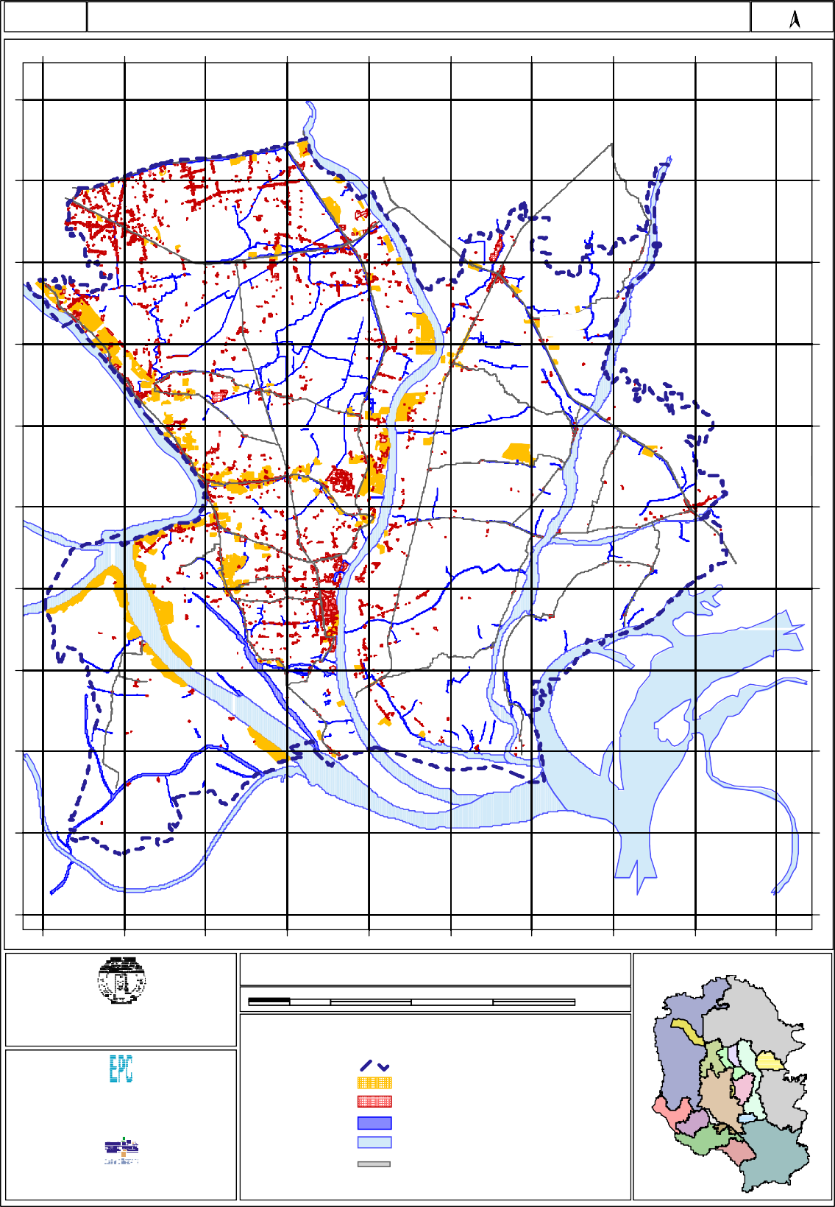
Map No: 2.2
0
0
0
2
6
5
0
0
0
0
6
5
0
0
0
8
5
5
0
0
0
6
5
5
0
0
0
4
5
5
0
0
0
2
5
5
0
0
0
0
5
5
0
0
0
8
4
5
0
0
0
6
4
5
0
0
0
4
4
5
Existing Commercial & Industrial Landuse Map

0
0
0
4
2
6

Demra
N

Ta ra bo ( Rupganj)

Jampur ( Sonargaon)

Jatrabari
0
0
0
2
2
6

Demra ( Part of DCC)

Kac hpur (Sonargaon)

Sadi pur
0
0
0
0
2
6
Sonargaon

Madan pur

Subhadya (Keraniganj)
0
0
0
8
1
6

Kutu bpur

Siddirganj Paur ashava

Dhamgar

Dhamgar

Sona rgaon

San mandi
0
0
0
6
1
6

Bandar

Ami npur

Musapur

Konda (Keraniganj)

Fatu llah
0
0
0
4
1
6

Mugra Para

Sonargaon

En ayetnagar
0
0
0
2
1
6

Band ar

Pirijpu r

Narayanganj Sadar
Balur Char (Serajdi khan)

Kaship ur

Narayanganj Paurashava
S HITA LAK HYA RIV ER

Sh ambh upura

Baktab al li
0
0
0
0
1
6

Kadam Rasul Paurashava

Kalagachhi a
OLD

Gog nagar

Hoss aindi ( Gaz aria)

Al irtek
0
0
0
8
0
6

Bayaragadi (Serajdi khan)

Muk tar pur Ferry G hat

Rek abi Ba zar
0
0
0
6
0
6
( Munshiganj Sadar)

Pa nchasar
( Munshiganj Sadar)

RIVER

Munshiganj Paurashava
ME GH NA RIV ER

Betka( Tongibari)
0
0
0
4
0
6

Detaile d Area Plan for DMDP Area (Group - B)

Index Map
0
0
0
2
6
5
0
0
0
0
6
5
0
0
0
8
5
5
0
0
0
6
5
5
0
0
0
4
5
5
0
0
0
2
5
5
0
0
0
0
5
5
0
0
0
8
4
5
0
0
0
6
4
5
0
0
0
4
4
5

Government of the People's Republic of Bangladesh Ministry of Housing and Public Works
Rajdhan i Unnayan Kartripa kkha (RAJUK)

2 0 2 4 6 Kilometers

LEGEND

Engineering & Planning Consultants Ltd.
House No. 7/4, Block-A, Lalmatia Dhaka 1207, Bangladesh
I n A s s o c i a t i o n W i t h

Data Experts (Pvt.) Limited
House No. 25/3, Road No. 15 New (28 Old), Dhanmondi Dhaka 1209 Bangladesh

Group- B Boundary Industrial Activity Commercial Activity Khal
River
Major Road Network

