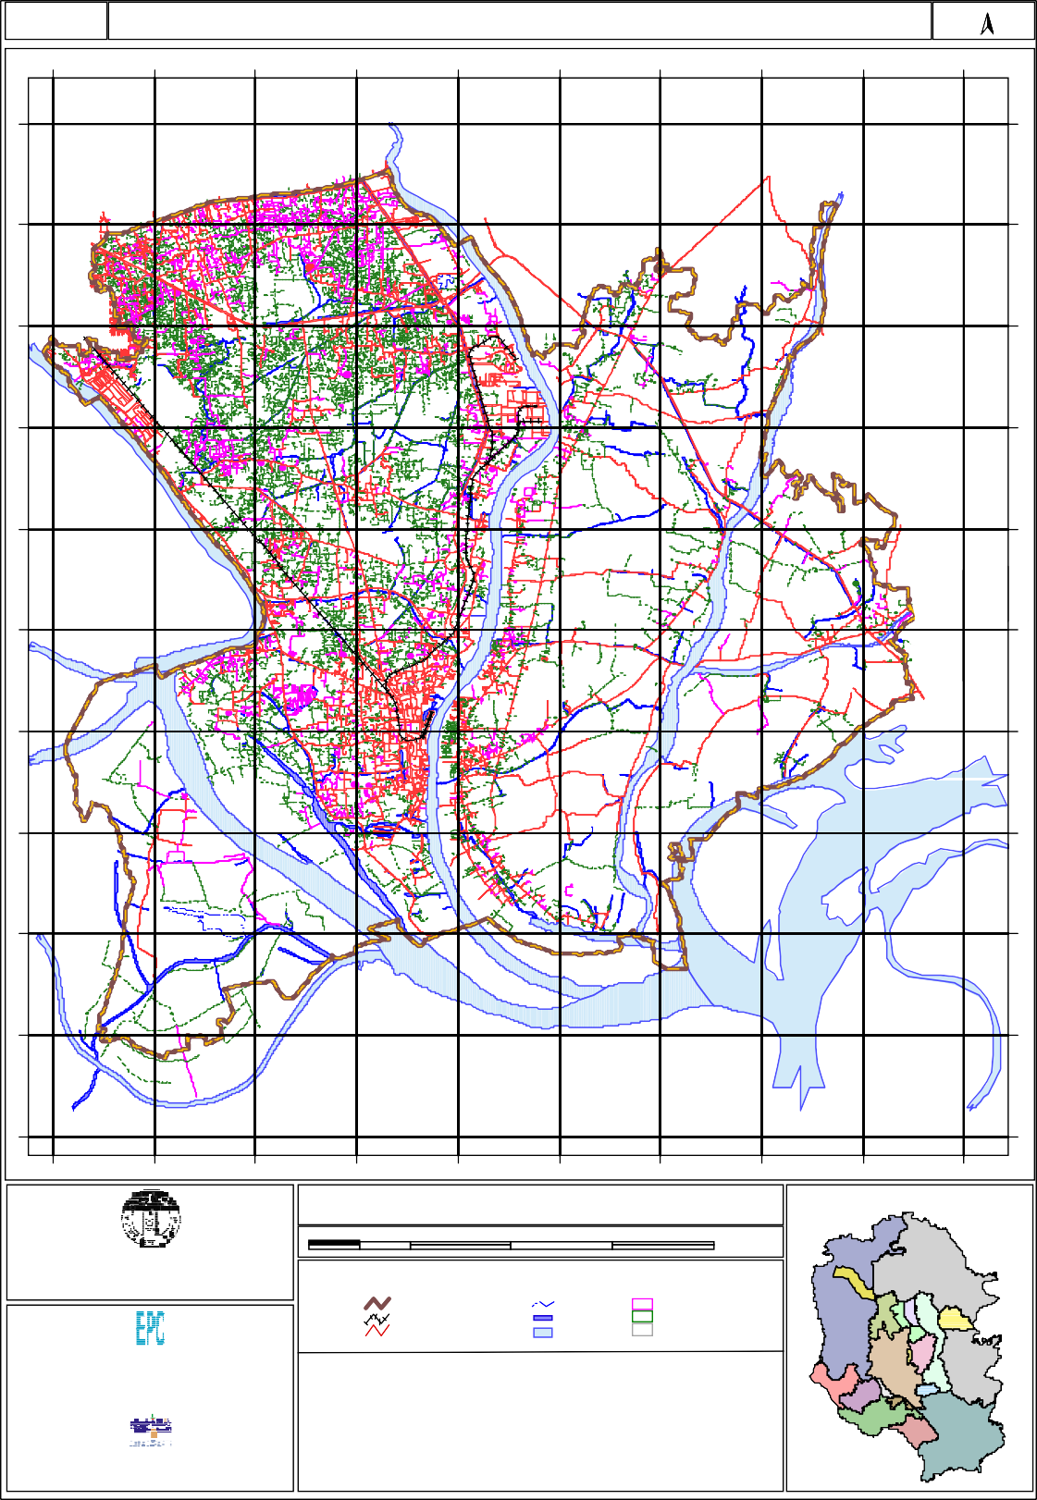Map No: 2.3

Existing Road Network

0
0
0
4
2
6

De mra
N

Ta ra bo ( Rupganj)

Jampur ( Sonargaon)

Ja trabari
0
0
0
2
2
6

Demra

Kac hpur (Sona rgaon)

Sadipur
0
0
0
0
2
6
Sonargaon

Madanpur

Subhadya (Ke raniganj)
0
0
0
8
1
6

Siddirganj Paurashava

Dhamgar

Kutubpur

Dhamgar

Sona rga on

Sanmandi
0
0
0
6
1
6

Bandar

Ami npur

Musapur

Konda (Keraniganj)

Fatullah
0
0
0
4
1
6

Mugr a Para

Sonargaon

Enayetnagar

Bandar

Pi rijpur

Narayanganj Sadar
0
0
0
2
1
6
Balur Cha r (Sera jdi khan)

Kashipur

Narayanganj Paurashava
S HITA LAK HYA RIV ER

Shambhupura

Baktaballi
0
0
0
0
1
6

Kadam Rasul Paurashava

Kalagac hhia

Gognagar

Hoss aindi ( Gaz aria)

Alirtek
0
0
0
8
0
6

Bay aragadi (Serajdi khan)

Muk tar pu r Ferry G hat

Rek abi Bazar
0
0
0
6
0
6
( Munshiganj Sadar)

Panchasar
( Munshiganj Sadar)

RIVER

Munshiganj Paurashava
ME GH NA RIV ER

Betk a( Tongibari)
0
0
0
4
0
6

Detaile d Area Plan for DMDP Area (Group - B)

Index Map

Government of the People's Republic of Bangladesh Ministry of Housing and Public Works
Rajdhan i Unnayan Kartripa kkha (RAJUK)

2 0 2 4 6 Kilometers

LEGEND

Engineering & Planning Consultants Ltd.
Dhaka 1 207, Bangladesh  I n A s s o c i a t i o n W i t h |  | Type  Pucca | Length (km)  534.75 | Area (acres)  163.43
 |  | H.B.B. | 1853.88 | 477.963
Data Experts (Pvt.) Limited |  | Kuctha | 1108.55 | 637.172
House No. 25/3, Road No. 15 New (28 Old), Dhanmondi Dhaka 1209 Bangladesh |  | Total | 3497.18 | 1278.565

DAP Group Boundary Railway
Road (Major)
Beel Khal River
Pucc a Road
H.B.B. Road Kutc ha Road

House No. 7/4, Block-A, Lalmatia
STATIST ICS

Group - B

Railway
Narayanganj has a railhead since its introduction in the country and it was one of the terminal stations of the Eastern Bengal Railway. In the fifties of the last century, rail connection was extended up to Adamjee Jute Mills and later it was connected with the Siddhirganj Silo situated further north of the Adamjee Jute Mills. However, the Adamjee Nagar section of the rail link was used for goods trains only and presently lies in a dilapidated condition and for the last 2/3 years trains do not ply in this track.

At present Narayanganj-Dhaka section of the railway is operated mostly for passenger traffic and all are local trains. Ticketing has been given to private operators. Seven pairs of trains are operated on week days and on weekly holidays only three pairs of trains are operated. The railway stations in the area are Narayanganj, Chashara, Fatulla and Pagla. Pagla is a flag station without any shunting facility.

The entire railway track is in a dilapidated condition. There is no ballast in the track. The entire length of the track is used as pedestrian path which causes damage to the embankment and makes movement of trains risky. Moreover, due to defects in the track, trains move quite slowly. The Railway Authority, in the past has tried to abandon this section several times. But due to popular demand, authority has been compelled to continue the rail services in this section. Demand for rail service is quite high, but due to poor service facilities, longer journey time and irregular service, it is not very popular among the commuters of Narayanganj town. However, with improved services, the railway could become a widely used mode of transport, especially to the commuters and the people living in the DND area. In the Group-B area there was another rail line connecting Narsingdi with Madanganj in the east bank of Sitalakhya river. This line was abandoned and now has been converted to a road.

Most of the facilities installed in the Narayanganj Railway Station have been withdrawn and a substantial area of the station has been leased out to the traders of bulk commodities, mostly fertilizer. The station had inter-modal transfer facility.

Water Way
Much of the importance of Narayanganj is owing to its excellent performance as ariver port. In the past, due to its efficiency and amount of export cargo, it was declared a port under Sea Customs Act. At present, mostly due to decline of jute sector, Narayanganj port has lost its position as prime river port of the country. The facilities installed in the port are presently underutilized.

The area is covered by two important river routes, one through Buriganga river and the other through Sitalakhya river. All vessels travelling from Dhaka to the southern districts has to pass through the Group-B section of the Buriganga river and some of them call Fatullah ghat.

Passenger Routes
Passengers are carried out by two different routes. One is Sadarghat Terminal based through Buriganga river, the other is Narayanganj based through Sitalakhya river. The routes are:

Launch Service from Dhaka-
- Dhaka-Barisal via Fatullah
- Dhaka-Patuakhali via Fatullah
- Dhaka-Chandpur via Fatullah
- Dhaka-Munshiganj via Fatullah
- Dhaka-Matlab via Fatullah
- Dhaka-Taltala via Fatullah

(Only those which call Fatullah, BIWTC operated passenger vessels do not call Fatullah ghat)

Narayanganj Water Works was commissioned in the year 1907 in the west bank of Sitalakhya river at Godenail. Distribution pipe lines covered almost all the major roads of the town. To meet the increased demand for potable water, ground water source was also utilized and a number of deep tube wells were installed. In the late eighties of the last century the Godenail Water Works was reconstructed with the assistance of Japanese Government. As a part of the reconstruction programme, several over-head tanks were constructed and new larger diameter distribution pipe network was laid.

WASA Water Works in Kadam Rasul Paurashava is located in the Sonakanda on the east bank of the Sitalakhya river. The Water Works was commissioned in the year 1931 with a capacity of 1.75 lac gallons daily. At present the water works is out of commission and water is supplied from ground water source.

Dhaka WASA has also introduced piped water supply system in parts of DND Triangle North extracting ground water sources. The coverage is for a small part of DND area which is characterized by irregular supply. The Urban Area Plan reports that public water supply system was extremely inadequate and the situation has not changed much since then.

Launch Service from Narayanganj-
- Narayanganj-Chandpur
- Narayanganj-Matlab
- Narayanganj-Ramchandrapur
- Narayanganj-Taltala
- Narayanganj-Serajdikhan
- Narayanganj-Sureshwar
- Narayanganj-Munshiganj

All the passenger services are operated by private operators and the Group-B area is not covered by BIWTC service though its vessels pass through the area. This part of the Circular Water Ways has not been commissioned yet.

Cargo Service
Various types of cargos are transported through Narayanganj Port. But there is no regular cargo service for carrying commodities. Commodities are generally carried by private arrangements and berthing facilities provided by the BIWTA are used for loading and unloading purposes. Many business houses or industries use private berthing facilities. Regular cargo service is operated between Kolkata and Narayanganj under Protocol arrangement. Vessels traveling to Chattack from Kolkata also call at Narayanganj as Narayanganj is the port of call for the river transit with India.

A substantial amount of cargos are transported through Engine Boats popularly known as Trawller or Cargo or Bulkhead. A huge number of such boats ply in the Sitalakhya river and carries construction materials, mostly, fill materials. There is no account of the number of such boats as there is no rule for registration of engine boats with less than 16 horse power engine. Country boats with sail, at present, are rarely found.

Terminal and Ghats
BIWTA is responsible for providing jetty facilities. In Narayanganj, the Terminal Building is equipped with berthing facilities for passenger launches. Other passenger loading and unloading facilities within the area are located in Fatullah and Madanganj.

For loading and unloading, BIWTA jetties are available in the Narayanganj Terminal Area known as Ghat no.5 and in Khanpur riverfront. These facilities are available to general public on payment of prescribed fees.

The riverside factories, industries and trading houses have their own individual jetty which they use for loading and unloading of their own cargos. Padma and Jamuna Oil Companies have their own berthing arrangement for oil tankers.

Inter Modal Transfer Facility
The Sitalakhya river route covers about 19 km from Demra to the confluence of Sitalakhya-Dhaleshwari and the Buriganga route covers from Shyampur to Munshiganj via Fatullah. There is no jetty facility for cargo provided by BIWTA in the Group-B area portion of the Buriganga river. However, almost the entire length of the Buriganga river bank is provided with landing facilities by private arrangements. On the other hand in the Narayanganj portion river route inter modal transfer facility is available in the Narayanganj Terminal and the Khanpur BIWTA Jetties.

Utility Services Water Supply
In the Group-B area Dhaka WASA is responsible for supply of drinking water in the urban areas. At present, WASA is operating three separate piped water supply system extracting water from Sitalakhya river and a number of deep tube wells (Map No. 2.4). DPHE operates in the areas not covered by WASA. A large number of individuals are also extracting water from private tube wells. WASA is operating in the following areas:

- Narayanganj Paurashava
- Kadam Rasul Paurashava
- North-west part of DND Triangle

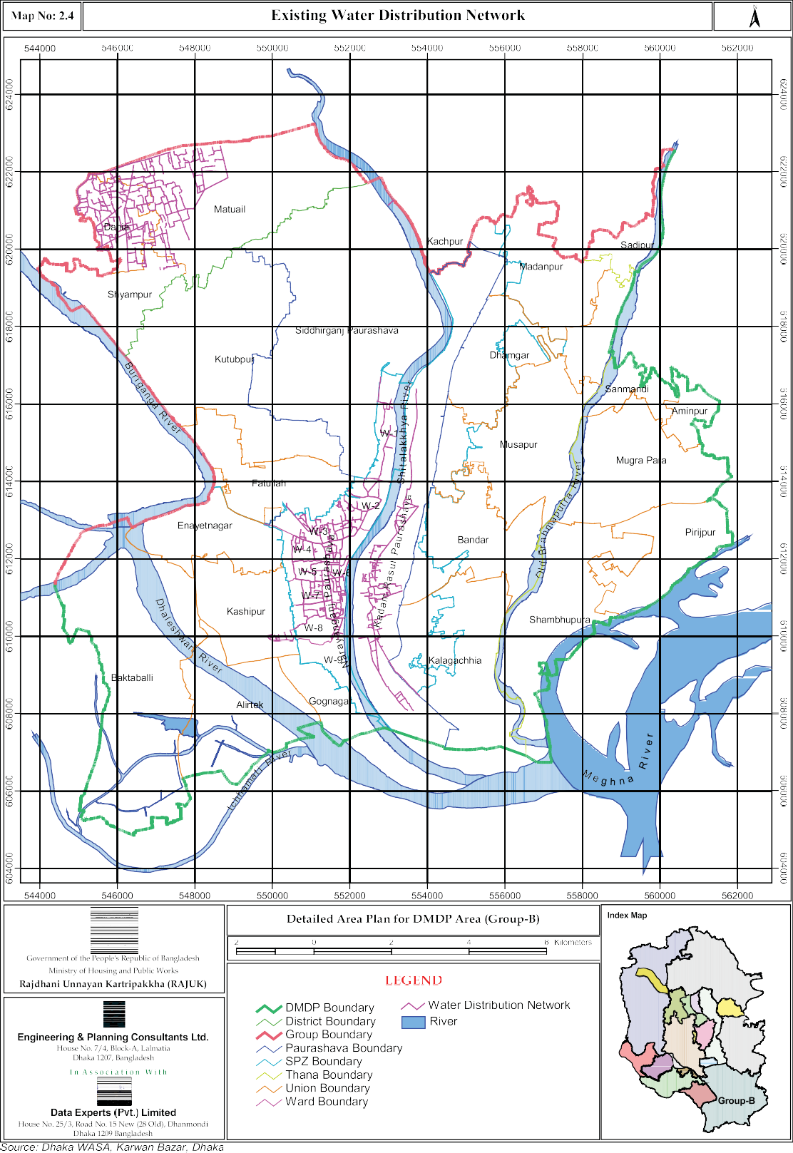

Electricity
The Bangladesh Power Development Board (BPDB) is responsible for generation of electricity for whole of the country while Dhaka Power Distribution Company Limited (DPDCL) and Rural Electrification Board (REB) are responsible for transmission, distribution of electricity in the Dhaka urban area/immediate surroundings and rural areas respectively.

The paurashava areas of Narayanganj are extensively covered by electricity network. Other paurashavas like Kadam Rasul and the newly formed Siddhirganj Paurashava is also adequately covered by the electricity distribution network. The whole of DND, excepting interior rural areas, the Group-B part of RAJUK jurisdiction is covered by electricity service network. The electricity network includes transmission line through poles above ground and in places through underground cables. There are sub-stations and generation units in the Group-B area. The Siddhirganj Power Station and the Haripur Power Station are two major generation units of the country located in the Group-B area.

Gas
The nationalized Titas Gas Transmission & Distribution Company Limited (TGTDC) is responsible for supply of gas in the Group-B project area. TITAS gas main distribution network covers Narayanganj and adjoining areas. TGTDC first started commercial operation with the commissioning of a gas supply line to Siddhirganj Thermal Power Station on 28 April, 1968.

Generally Narayanganj Paurashava and adjoining areas, Kadam Rasul Paurashava areas were extensively brought under coverage by gas distribution network. Gas is now available in all the important urban areas and industrial belt of the Group-B area (Map No. 2.5).

Drainage
Road side drains are available in the Narayanganj Paurashava and the Kadam Rasul Paurashava. These drains are not properly maintained and mostly do not reach the outfall uninterrupted. Naturally water logging and over spill is common. Situation is going to be further aggravated due to encroachment in to canals and filling up of low lying areas presently serving as out falls. On the other hand newly created Siddhirganj Paurashava has initiated the work of construction of road side drains. For drainage improvement in the DND area, BWDB has taken a project and feasibility studyof the project is presently being carried out. Other areas of the Group-B are covered by natural drainage through gravity flow.

Sewerage
Group-B area is not covered by Sewerage Network though the lone Sewage Treatment Plant in the Metropolitan Area is located in the Pagla area. The treatment capacity of the Pagla Sewage Treatment Plant is 116 MLD and reportedly it is running at its full discharge capacity. There is no scheme by WASA to bring the Group-B area under Sewerage network coverage.

Solid Waste
The generation of solid waste will continue to increase with the increase of population and urbanization. If these wastes are not properly managed, it can have serious detrimental effects on the environmental quality. In the rural areas, there
are low lying vacant lands alongside almost all the households and solid wastes are dumped there. In Group-B area solid waste collection and disposal system exists only in Narayanganj Paurashava area operated by Narayanganj Paurashava. But a substantial amount of solid waste that are generated daily are not collected and disposed off which eventually find their ways into road side drains or canals or incidental spaces or in vacant plots in between settlements. This makes the urban living hazardous.

The usual practice of solid waste disposal is first collection from individual households and dumping them in designated places mostly alongside some selected roads or bins. Then the collected solid wastes are transported to permanent dumping ground located at a distance. Solid Waste Disposal through door to door collection by rickshaw van is also prevalent in Narayanganj Paurashava area. The localities like Chashara, Mission Para, Dawn Chamber, Amla Para, Tolaram College and parts of Masdair are covered by the door to door collection system.

At present two locations are used for dumping of solid waste in Narayanganj. One is a Narayanganj Paurashava owned dumping site located outside the municipal area at Panchabati alongside the Panchabati-Munshiganj Road near the BSCIC Industrial Estate. The other one is located in the east side of the Narayanganj Link Road about 100m north of the Fatullah Stadium. In Narayanganj Town there is no site for controlled dumping of solid waste.

The Urban Area Plan describes the situation as unsatisfactory and comments, “During the coming years the respective agencies have to embark on development schemes that reduce the alarming and deteriorating health risks caused by poor sanitary conditions. This needs to be done on a city wide scale, as almost all urban areas are threatened and there should be a concerted effort by the technical agencies, public health, education and social affairs. Scale of intervention and coordination between the involved agencies need urgent attention”.

Telephone
The capacity of Narayanganj Telephone Exchange has been extended by 16000 new digital telephone lines. Several Sub Exchange Offices has been setup at different places resulting in improved service by Bangladesh Telecommunication Company Limited (BTCL). Moreover, extensive service by private operators has changed the situation dramatically. At present the entire Group-B area is covered by cellular phone network by private operators.

Land Ownership and Value

Land ownership in the area is mixed but overwhelming biased towards private individual ownership. Lands are owned by government agencies (various sector corporations), local administration, khas land (according to Khas Khatian), private developers and private individuals. Khas khatian of the area indicated a very small amount of khas land, most of which are at present under illegal occupation. Map No. 2.6 shows the locations of khas land and land under the ownership of various government agencies in dot form, as most of the khas land covers unidentified portion of a plot or plots. Among the government agencies large chunks of lands are owned by Water Development Board, Dhaka WASA (Sewage Treatment Plant at Pagla and Water Treatment Plants in Narayanganj and Kadam Rasul), Power Development Board (Siddhirganj and Haripur Power Station), BIWTA, BIWTC and Bangladesh Railway etc. Rest of the land is owned by private individuals who own land of various quantities.

Land value in the area depends on the location and accessibility. In rural areas value of agricultural land is comparatively less with wide variation ranging from Tk 1.0 lac to Tk 50.0 lacs per acre depending on irrigation and connectivity facilities. Land value in DND area ranges from Tk 0.50 lac to Tk 5.00 lacs per Katha depending on location and accessibility. Land value alongside the Dhaka-Chittagong road east of Kanchpur Bridge ranges from Tk 10.0 lac to Tk 15.0 lacs per acre depending on location. In the Narayanganj Paurashava area in certain locations, especially along side the major roads and commercial areas land value ranges from Tk: 25.0 to Tk: 75.0 lac per katha. Land value of flood free land is higher than the land of low lying areas. Land value has increased substantially due to presence of good number of affluent people who are buying land on speculation. This has also resulted in the further fragmentation of large agricultural plots. Land value is changing everyday and a sharp increase of land value has been recorded in the recent times.

